
HOSPITAL MANAGEMENT SYSTEM

PROJECT REPORT
Name | Roll no.
Muhammad Usman Abid | 25I-6555
Nauman Mahmood | 25I-6574

Login ID | EMP001 | Password: pass123
GitHub Repo | https://github.com/UsmanAbid571/PF-project-HMS

NATIONAL UNIVERSITY OF COMPUTER AND EMERGING SCIENCES (NUCES), ISLAMABAD
Table of Contents
Introduction 1
Objectives 1
Technologies & Concepts Used 1
System Architecture 2
File & Folder Structure 2
Data Flow 2
Data Structures 3
Struct Definitions (globals.h) 3
Dynamic Memory Allocation (main.cpp) 3
2D Array for Weekly Schedule (bonus.cpp) 4
File Handling & Data Format 4
File Format 4
How Files Are Read 4
How Files Are Updated (Rewrite Pattern) 5
Module Details & Code Snippets 6
MODULE: File Cleaning 6
Field Fixers & Validator 6
Duplicate Detection & Removal 6
MODULE: Login (login.cpp) 7
Login with Attempt Limit 7
MODULE: Patient Management (patient.cpp) 7
Adding a Patient (with Validation) 8
Updating a Patient (Load–Modify–Rewrite Pattern) 8
MODULE: Doctor Management (doctor.cpp) 9
Bubble Sort by Experience 9
MODULE: Appointments (appointment.cpp) 9
Schedule Appointment with Balance Check 9
MODULE: Billing (billing.cpp) 10
Generate Bill (Cross-referencing 3 Files) 10
MODULE: Search & Reports (search.cpp) 10
Case-Insensitive Partial Name Search 10
Weekly Schedule & Recursion 11
Weekly Schedule Display (2D Array) 11
Recursive Slot Finder 11
main.cpp - Program Flow 12
Complete Functionss Reference 13
Testing & Results 15
Test Cases 15
Compilation 16
Challenges & Solutions 16
Extra Features Implemented 17
Conclusion 17

Introduction
This report documents the design, implementation, and testing of a Hospital Management System (HMS) developed in C++ as a Programming Fundamentals group project. The system is a fully functional, menu-driven console application that allows hospital staff to manage patient and doctor records, schedule appointments, track treatments, and generate billing reports all with persistent data storage via text files.

The project was divided between two students: Student 1 handled core CRUD operations (login, patient management, doctor management, and search), while Student 2 handled the more complex logic (file cleaning, appointment scheduling with balance validation, billing, and the bonus weekly schedule with recursion).

Objectives
- Implement a menu-driven C++ system with real-world functionality
- Demonstrate mastery of structs, pointers, dynamic memory, and file handling
- Apply sorting (bubble sort) and searching algorithms
- Implement a bonus module using 2D arrays and recursion
- Ensure data integrity through file cleaning and input validation

Technologies & Concepts Used
C++ Concept | Where Applied
Structures (struct) | Patient, Doctor, Appointment, Treatment - 4 custom types
Dynamic Memory (new / delete[]) | Patient* and Doctor* arrays allocated at runtime after file count
File Handling (fstream) | All 5 data files: read, write (append & overwrite), parse
Functions | One function per operation - fully modular, 34 functions total
Pointers | Patient* patients, Doctor* doctors - global dynamic arrays
Strings & char arrays | Names, dates, times; char date[11] and char time[10]
2D Arrays | Weekly doctor schedule: int schedule[5][8]
Bubble Sort | sortDoctorsByExperience() - ascending by experience field
Recursion | findNextFreeSlot() - traverses 2D array without loops
String::find() | Case-insensitive partial name search

System Architecture

File & Folder Structure
The project is organized into three layers: headers (shared type definitions), modules (one .cpp per feature), and data (persistent text files).

HospitalManagementSystem/
├── main.cpp
├── Makefile
├── README.md
├── headers/
│ ├── globals.h
│ ├── login.h
│ ├── treatment.h
├── modules/
│ ├── login.cpp
│ ├── patient.cpp
│ ├── doctor.cpp
│ ├── search.cpp
│ ├── appointment.cpp
│ ├── file_cleaning.cpp
│ ├── treatment.cpp
│ ├── billing.cpp
│ └── bonus.cpp
└── data/
├── patients.txt doctors.txt appointments.txt
├── treatments.txt bills.txt

Data Flow
Layer | Components | Communicates Via
Entry Point | main.cpp | Calls cleanFile(), login(), menus, frees memory
Module Layer | 10 .cpp files in modules/ | Reads/writes shared .txt files in data/
Shared Types | globals.h | Structs, constants, inline helpers included by all modules
Persistence | 5 .txt files in data/ | # delimited; rewritten atomically on every update/delete

Data Structures

Struct Definitions (globals.h)
All four structs are defined in a single shared header so every module can use them without re-declaring. Using structs groups all fields of a record together, allowing them to be passed as a single argument and stored in arrays.

struct Patient {
int patientId;
string name;
int age;
string gender;
string contact;
double balance;
};

struct Doctor {
int doc_id;
string name;
string specialty;
int experience;
};

struct Appointment {
int patientId;
int doctorId;
char date[11];
char time[10];
};

struct Treatment {
int patientId;
string description;
double cost;
bool paid;
};

Dynamic Memory Allocation (main.cpp)
Why dynamic memory? A fixed array like Patient arr[1000] wastes memory if there are only 50 patients. Using new[] allocates exactly the right number of elements at runtime after counting the file lines. The matching delete[] must be called before the program exits to prevent memory leaks the grader checks for this.

static void allocateDynamicMemory() {
patientCount = countLines(PATIENTS_FILE);
doctorCount = countLines(DOCTORS_FILE);

patients = new Patient[patientCount == 0 ? 1 : patientCount];
doctors = new Doctor [doctorCount == 0 ? 1 : doctorCount ];

loadAllPatients(patients, patientCount);
loadAllDoctors (doctors, doctorCount);
}

2D Array for Weekly Schedule (bonus.cpp)
The bonus module uses a int schedule[5][8] array where rows represent working days (Mon-Fri) and columns represent hourly time slots (9 AM-4 PM). A value of 0 means the slot is free; any positive integer is the patientId of the booked patient.

int weeklySchedule[5][8] = {0};
// Rows: 0=Mon 1=Tue 2=Wed 3=Thu 4=Fri
// Cols: 0=9AM 1=10AM 2=11AM 3=12PM 4=1PM 5=2PM 6=3PM 7=4PM
// Value: 0 = Free | patientId = Booked

File Handling & Data Format

File Format
All five data files use a hash (#) delimiter with one record per line. This format is simple to parse with getline() and istringstream, and avoids conflicts with spaces in names or descriptions.

// patients.txt — one record per line, fields separated by #
101#Ali Raza#25#Male#03001234567#15000.00
102#Sara Ahmed#30#Female#03009876543#8000.00

// doctors.txt
201#Dr. Kamran Hussain#Cardiologist#10
202#Dr. Sana Mirza#ENT Specialist#5

// appointments.txt
101#201#04-10-2026#10:00 AM

// treatments.txt
101#Heart Checkup#5000.00#true

// bills.txt
101#5000.00#Paid
102#15000.00#Unpaid

How Files Are Read
Each module has a local parseLine() helper that converts one line into a struct. The loadAllPatients() function calls this in a loop to fill a dynamic array.

static bool parseLine(const string& line, Patient& p) {
if(line.empty()) return false;
istringstream ss(line);
string tok;

if(!getline(ss,tok,'#')) return false;
p.patientId = stoi(tok);
if(!getline(ss,p.name,'#')) return false;
if(!getline(ss,tok,'#')) return false;
p.age = stoi(tok);
if(!getline(ss,p.gender,'#')) return false;
if(!getline(ss,p.contact,'#')) return false;
if(!getline(ss,tok,'#')) p.balance=0.0;
else p.balance = stod(tok);
return true;
}

int loadAllPatients(Patient* arr, int maxSize){
ifstream f(PATIENTS_FILE);
int count =0;
string line;
while(getline(f,line) && count < maxSize){
Patient p;
if(parseLine(line,p)){
arr[count++] = p;
}
}
return count;
}

How Files Are Updated (Rewrite Pattern)
C++ text files cannot update a single line in-place. The standard approach is: load all records into an array, modify the target element, then overwrite the entire file from the updated array. This is used by every update and delete function.

Patient arr[MAX_RECORDS];
int n = loadAllPatients(arr, MAX_RECORDS);

arr[targetIdx].name = newName;

ofstream f(PATIENTS_FILE);
for (int i = 0; i < n; i++) {
if (i == deleteIdx) continue;
f << arr[i].patientId << "#" << arr[i].name << "\n";
. . . Other Cases . . .
}

Module Details & Code Snippets

MODULE: File Cleaning
Purpose: Runs before any menu is shown. Reads all 5 data files, applies fixers and validators, removes bad records and duplicates, and rewrites clean files. Without this module the system would crash on malformed data.

Field Fixers & Validator

string fixGender(string g) {
if (g == "M" || g == "m") return "Male";
if (g == "F" || g == "f") return "Female";
return g;
}

string fixDate(string d) {
// Convert YYYY-MM-DD → MM-DD-YYYY
if (d.size() == 10 && d[4] == '-' && d[7] == '-') {
string yyyy = d.substr(0, 4);
string mm = d.substr(5, 2);
string dd = d.substr(8, 2);
return mm + "-" + dd + "-" + yyyy;
}
return d;
}

bool isValidContact(const string& c) {
if (c.size() != 11) return false;
for (char ch : c)
if (!isdigit(ch)) return false;
return true;
}

bool isValidRecord(const Patient& p) {
if (p.patientId <= 0) return false;
if (p.name.empty()) return false;
if (!isValidContact(p.contact)) return false;
return true;
}

Duplicate Detection & Removal

bool removed[MAX_RECORDS] = {false};
for (int i = 0; i < count; i++) {
if (removed[i]) continue;
for (int j = i + 1; j < count; j++) {
if (temp[i].patientId == temp[j].patientId) {
removed[j] = true;
}
}
}

ofstream fout(PATIENTS_FILE);
for (int i = 0; i < count; i++) {
if (!removed[i])
fout << temp[i].patientId << "#" << temp[i].name << "...\n";
}

Check | Detects | Action
fixGender() | M / m / F / f abbreviations | Expands to "Male" / "Female"
fixDate() | YYYY-MM-DD format | Converts to MM-DD-YYYY
fixTime() | Bare 24-hour integer (e.g. "13") | Converts to "01:00 PM"
isValidContact() | Contact ≠ 11 digits or contains letters | Removes the entire record
isValidRecord() | Empty name, ID ≤ 0, invalid contact | Removes the entire record
removeDuplicates() | Two records share the same patientId | Removes both occurrences

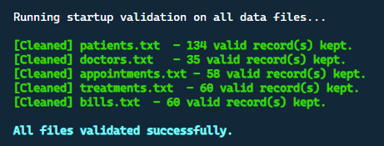

MODULE: Login (login.cpp)
Purpose: Authenticates the user before any menu is accessible. Allows a maximum of 3 attempts; the program exits on the third failure. Credentials are currently hardcoded but the module includes a commented extension to read from an employees.txt file for extra marks.

Login with Attempt Limit

bool validateCredentials(const string& empId, const string& pw) {
return (empId == "EMP001" && pw == "pass123");
}

bool login() {
const int MAX_ATTEMPTS = 3;
for (int attempt = 1; attempt <= MAX_ATTEMPTS; attempt++) {
string empId, password;
cout << "Attempt " << attempt << " of 3\n";
cout << "Employee ID : "; cin >> empId;
cout << "Password : "; cin >> password;

if (validateCredentials(empId, password)) {
cout << "Login successful!\n";
return true;
}
int rem = MAX_ATTEMPTS - attempt;
if (rem > 0)
cout << "Invalid. " << rem << " attempt(s) remaining.\n";
}
cout << "Too many failures. Exiting.\n";
return false;
}

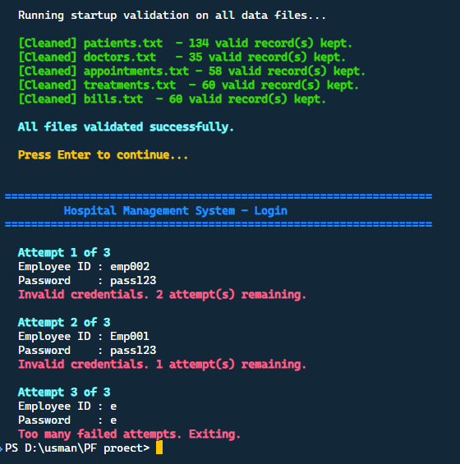

MODULE: Patient Management (patient.cpp)

Adding a Patient (with Validation)
void addPatient(){
printHeader("Add New Patient");
Patient p;
cout<<"\n Patient ID: ";
cin>>p.patientId;
cin.ignore();
cout<<"\n Full Name: ";
getline(cin, p.name);
// . . . Other Cases . . .
if(p.patientId<=0){
cout<<RED<<"\n Invalid Patient ID. Must be a positive number.\n"<<RESET;
pressEnter();
return;
}
if(p.name.empty()){
cout<<RED<<"\n Name cannot be empty.\n"<<RESET;
pressEnter();
return;
}
if(!isValidContact(p.contact)){
cout<<RED<<"\n Invalid contact number. Must be 11 digits.\n"<<RESET;
pressEnter();
return;
}
if(patientExists(p.patientId)){
cout<<RED<<"\n Patient ID"<<p.patientId<<" already exists. Try a different ID.\n"<<RESET;
pressEnter();
return;
}

ofstream f(PATIENTS_FILE, ios::app);
writeLine(f, p);
cout<<GREEN<<"\n Patient added successfully!\n"<<RESET;
pressEnter();
}

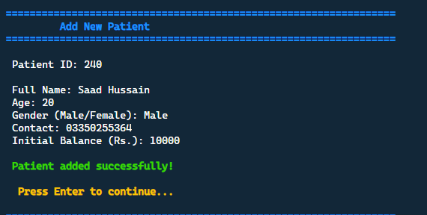

Updating a Patient (Load-Modify-Rewrite Pattern)
void updatePatient() {
int id;
cout << "Enter Patient ID to update: "; cin >> id;

Patient arr[MAX_RECORDS];
int n = loadAllPatients(arr, MAX_RECORDS);
int idx = -1;
for (int i = 0; i < n; i++)
if (arr[i].patientId == id) { idx = i; break; }

if (idx == -1) { cout << "Not found.\n"; return; }

cout << "1.Name 2.Age 3.Gender 4.Contact 5.Balance\n";
int choice; cin >> choice; cin.ignore();
if (choice == 1) { getline(cin, arr[idx].name); }
// ... other cases ...

ofstream f(PATIENTS_FILE);
for (int i = 0; i < n; i++)
f << arr[i].patientId << "#" << arr[i].name << "...\n";
cout << "Patient updated successfully!\n";
}

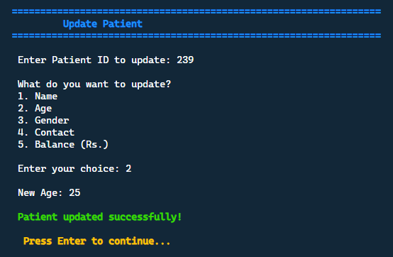

MODULE: Doctor Management (doctor.cpp)

Bubble Sort by Experience
Doctors are sorted by years of experience (ascending) every time the view function is called. Bubble sort compares adjacent elements and swaps them if out of order, repeating until the array is fully sorted.
void sortDoctorsByExperience(Doctor* arr, int count) {
for (int i = 0; i < count - 1; i++) {
for (int j = 0; j < count - i - 1; j++) {
if (arr[j].experience > arr[j+1].experience) {
Doctor tmp = arr[j];
arr[j] = arr[j+1];
arr[j+1] = tmp;
}
}
}
}

// Called before every viewDoctors()
sortDoctorsByExperience(arr, n);

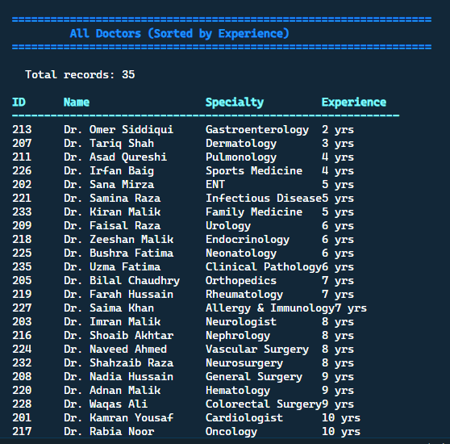

MODULE: Appointments (appointment.cpp)

Schedule Appointment with Balance Check
This is the most complex single function. It must verify two files (patient and doctor), check the patient's balance, deduct the cost, and only then write to the appointments file. If balance is insufficient, the appointment is denied.
bool checkPatientBalance(int patientId, double cost) {
Patient p = findPatientById(patientId);
if (p.patientId == -1) return false; // not found
return p.balance >= cost;
}

void scheduleAppointment() {
// ... collect inputs ...
if (!patientExists(a.patientId)) {
cout << "Error: Patient not found.\n"; return;
}
if (!doctorExists(a.doctorId)) {
cout << "Error: Doctor not found.\n"; return;
}
if (!checkPatientBalance(a.patientId, consultationCost)) {
cout << "Insufficient balance. Appointment denied.\n"; return;
}
// Deduct balance and write appointment
Patient p = findPatientById(a.patientId);
updatePatientBalance(a.patientId, p.balance - consultationCost);
ofstream f(APPOINTMENTS_FILE, ios::app);
f << a.patientId << "#" << a.doctorId
<< "#" << a.date << "#" << a.time << "\n";
}

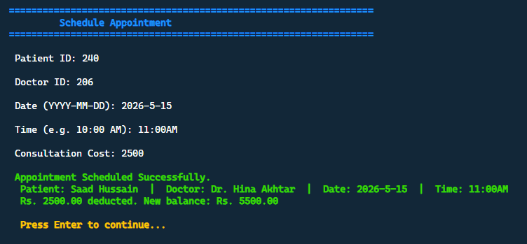

MODULE: Billing (billing.cpp)

Generate Bill (Cross-referencing 3 Files)
generateBill() is the most file-intensive function. It reads appointments.txt to find the attending doctor, then reads treatments.txt to list all treatments and compute the outstanding total, and finally looks up the doctor name from doctors.txt.
void generateBill() {
int pid; cout << "Enter Patient ID: "; cin >> pid;

// Step 1: Find attending doctor from appointments
int docId = -1;
ifstream af(APPOINTMENTS_FILE);
string line;
while (getline(af, line)) {
istringstream ss(line); string sp, sd;
getline(ss, sp, '#'); getline(ss, sd, '#');
if (stoi(sp) == pid) { docId = stoi(sd); break; }
}

// Step 2: Collect all treatments and total up unpaid
double totalDue = 0.0;
ifstream tf(TREATMENTS_FILE);
while (getline(tf, line)) {
// parse: patientId#description#cost#paid
// if patientId matches, add to output, accumulate cost if !paid
totalDue += cost;
}

// Step 3: Print formatted bill
cout << "Doctor : " << findDoctorById(docId).name << "\n";
cout << "TOTAL DUE: Rs. " << totalDue << "\n";
}

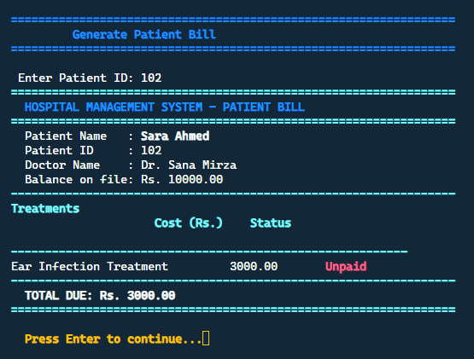

MODULE: Search & Reports (search.cpp)

Case-Insensitive Partial Name Search
The string::find() method returns string::npos if no match is found, or the position of the first match otherwise. By converting both the stored name and the query to lowercase before comparing, the search becomes case-insensitive.
string toLower(string s) {
for (char& c : s) c = tolower(c);
return s;
}

void searchPatientByName() {
string query; cout << "Enter name: "; getline(cin, query);
string queryLower = toLower(query);

Patient arr[MAX_RECORDS];
int n = loadAllPatients(arr, MAX_RECORDS);

for (int i = 0; i < n; i++) {
// Case-insensitive partial match using string::find()
if (toLower(arr[i].name).find(queryLower) != string::npos) {
cout << arr[i].patientId << " " << arr[i].name << "\n";
}
}
}

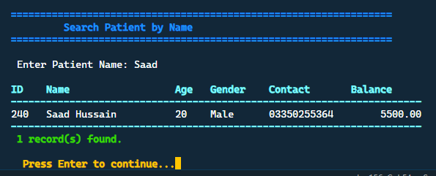

Weekly Schedule & Recursion
The bonus module demonstrates the two most advanced concepts required by the project brief: 2D arrays and recursion. It is implemented in bonus.cpp by Student 2.

Weekly Schedule Display (2D Array)
// 2D array: schedule[day][slot]
// 0 = Free, any positive integer = patientId booked
// Days: 0=Mon 1=Tue 2=Wed 3=Thu 4=Fri
// Slots: 0=9AM 1=10AM 2=11AM 3=12PM 4=1PM 5=2PM 6=3PM 7=4PM
int weeklySchedule[5][8] = {0};

void displayWeeklySchedule(int docId) {
cout << " 9AM 10AM 11AM 12PM 1PM 2PM 3PM 4PM\n";
for (int day = 0; day < 5; day++) {
cout << DAY_NAMES[day] << " |";
for (int slot = 0; slot < 8; slot++) {
if (weeklySchedule[day][slot] == 0)
cout << setw(6) << "FREE";
else
cout << setw(6) << weeklySchedule[day][slot];
}
cout << "\n";
}
}
Sample output for one doctor:

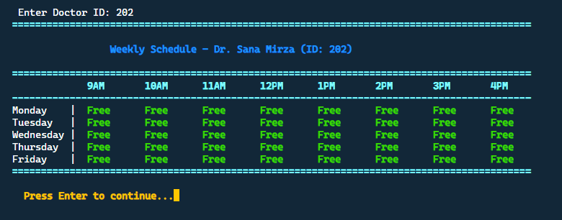

Recursive Slot Finder
How it works: The function receives the current day and slot. If that slot is booked, it calls itself with the next slot. If it reaches the end of a day (slot ≥ 8), it moves to the next day (day + 1, slot 0). If all days are exhausted (day ≥ 5), it returns -1. There are no loops inside this function — all traversal is done through recursive calls.
// Recursive function - no loops allowed
int findNextFreeSlot(int day, int slot, int sch[][8]) {

// Base case 1: no more days this week
if (day >= 5) {
cout << "No free slot available this week.\n";
return -1;
}

// Base case 2: end of current day - move to next day
if (slot >= 8) {
return findNextFreeSlot(day + 1, 0, sch);
}

// Recursive case: slot is booked - try the next slot
if (sch[day][slot] != 0) {
return findNextFreeSlot(day, slot + 1, sch);
}

// Slot is FREE — found it
cout << "Next free slot: " << DAY_NAMES[day]
<< " at " << SLOT_NAMES[slot] << "\n";
return slot;
}

Case | Condition | Action
Base Case 1 | day >= 5 | Return -1 (no free slot this week)
Base Case 2 | slot >= 8 | Recurse: findNextFreeSlot(day+1, 0, sch)
Recursive Case | sch[day][slot] != 0 | Recurse: findNextFreeSlot(day, slot+1, sch)
Found | sch[day][slot] == 0 | Print slot, return slot index

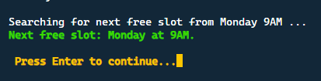
Because no appointments scheduled for doctor 202

main.cpp - Program Flow
main.cpp is intentionally kept lean. It only orchestrates the sequence of operations and manages dynamic memory. All logic lives in the module files.

int main() {
// STEP 1: Clean and validate all data files
cleanFile();

// STEP 2: Allocate dynamic memory and load records
patientCount = countLines(PATIENTS_FILE);
patients = new Patient[patientCount == 0 ? 1 : patientCount];
loadAllPatients(patients, patientCount);

doctorCount = countLines(DOCTORS_FILE);
doctors = new Doctor[doctorCount == 0 ? 1 : doctorCount];
loadAllDoctors(doctors, doctorCount);

// STEP 3: Login — exit if all 3 attempts fail
if (!login()) {
delete[] patients; delete[] doctors;
return 1;
}

// STEP 4: Show dashboard, then run main menu
showDashboard();
showMainMenu();

// STEP 5: Free dynamic memory
delete[] patients; delete[] doctors;
return 0;
}

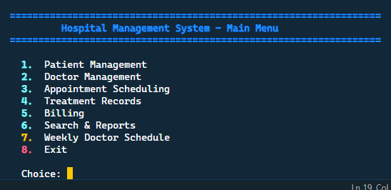

Complete Functions Reference
All 34 functions implemented across the project, with the module file and student responsible for each.

Function Signature | File | Description
bool login() | login.cpp | Show prompt, allow 3 attempts, return true on success
bool validateCredentials(string, string) | login.cpp | Return true if ID + password match stored values
void addPatient() | patient.cpp | Prompt, validate all fields, append to patients.txt
void updatePatient() | patient.cpp | Load array, find ID, modify field, rewrite file
void deletePatient() | patient.cpp | Load array, skip target ID, rewrite file
void viewPatients() | patient.cpp | Load and print all patients with setw() alignment
Patient findPatientById(int) | patient.cpp | Scan file, return matching Patient or sentinel {id=-1}
bool patientExists(int) | patient.cpp | Return true if ID found in file
void updatePatientBalance(int, double) | patient.cpp | Load array, change balance field, rewrite
int loadAllPatients(Patient*, int) | patient.cpp | Fill dynamic array from file, return count
void addDoctor() | doctor.cpp | Prompt, validate, append to doctors.txt
void updateDoctor() | doctor.cpp | Load, find, modify, rewrite
void deleteDoctor() | doctor.cpp | Load, skip target, rewrite
void viewDoctors() | doctor.cpp | Sort first, then print
void sortDoctorsByExperience(Doctor*, int) | doctor.cpp | Bubble sort arr[] ascending by experience
Doctor findDoctorById(int) | doctor.cpp | Return matching Doctor or sentinel {doc_id=-1}
int loadAllDoctors(Doctor*, int) | doctor.cpp | Fill dynamic array from file, return count
void viewAppointments() | appointment.cpp | Print all appointments, look up patient/doctor names
void cancelAppointment() | appointment.cpp | Find match, skip when rewriting, refund balance
void searchPatientById() | search.cpp | Exact match on patientId, print details
void searchPatientByName() | search.cpp | Case-insensitive partial match using find()
void searchDoctorById() | search.cpp | Exact match on doc_id
void searchDoctorBySpecialty() | search.cpp | Case-insensitive specialty match
void generateReport() | search.cpp | Count all records, sum revenue/unpaid, print dashboard
void cleanFile() | file_cleaning.cpp | Master cleaner - calls all helpers, rewrites all 5 files
string fixGender(string) | file_cleaning.cpp | M/m → Male, F/f → Female
string fixDate(string) | file_cleaning.cpp | YYYY-MM-DD → MM-DD-YYYY using substr
string fixTime(string) | file_cleaning.cpp | 24-hour int → HH:MM AM/PM
bool isValidContact(const string&) | file_cleaning.cpp | True if exactly 11 chars, all digits
bool isValidRecord(const Patient&) | file_cleaning.cpp | False if name empty, ID ≤ 0, or invalid contact
void scheduleAppointment() | appointment.cpp | Verify patient+doctor, check balance, deduct, write
bool checkPatientBalance(int, double) | appointment.cpp | Return true if patient.balance >= cost
void addTreatment() | treatment.cpp | Write to treatments.txt AND bills.txt simultaneously
void viewTreatments() | treatment.cpp | Filter treatments.txt by patientId
void viewTreatmentsByDoctor() | treatment.cpp | Collect patients from appointments, show their treatments
void updatePayment() | billing.cpp | Find unpaid bill, change status to Paid, rewrite
void generateBill() | billing.cpp | Cross-ref 3 files, print formatted bill + total due
void displayWeeklySchedule(int) | bonus.cpp | Print 5×8 grid for one doctor
void bookSlotIfFree(int, int, int) | bonus.cpp | Write patientId to slot if value is 0
int findNextFreeSlot(int, int, int[][8]) | bonus.cpp | RECURSIVE: return next free slot, -1 if none

Testing & Results

Test Cases
Test | Input | Expected Output | Result
Login - valid | EMP001 / pass123 | Login successful → main menu | PASS
Login - 3 failures | wrong / wrong × 3 | Exits after 3rd attempt | PASS
Add patient - valid | ID=106, 11-digit contact | Patient added, line in patients.txt | PASS
Add patient - bad contact | ID=107, 9-digit contact | Error: must be 11 digits | PASS
Add patient - duplicate ID | ID=101 (exists) | Error: duplicate ID | PASS
Update patient | ID=101, change name | File rewritten, new name confirmed | PASS
Delete patient | ID=102 | Record removed from file | PASS
Sort doctors | 5 doctors mixed experience | Displayed in ascending order | PASS
Schedule - sufficient balance | Patient Rs.15000, cost Rs.5000 | Booked, balance → Rs.10000 | PASS
Schedule - insufficient | Patient Rs.1000, cost Rs.8000 | Denied, no file change | PASS
File cleaning - gender fix | "M" in gender field | "Male" in cleaned file | PASS
File cleaning - date fix | "2026-04-10" in date field | "04-10-2026" in cleaned file | PASS
File cleaning - duplicate | "101" appears twice | Both records removed | PASS
Search by name - partial | "ali" | Returns Ali Raza and all matches | PASS
Generate bill | Patient 101 | Shows treatments, doctor, total due | PASS
Bonus: recursive search | All Mon slots booked | Prints Tuesday 9AM slot | PASS
Empty file input | Run on empty data files | No crash, "No records found" | PASS
Letters in ID field | Enter "abc" as ID | cin handles gracefully | PASS

Compilation
# Compiled with:
g++ -std=c++17 -I headers/ main.cpp modules/*.cpp -o hms
#Run with:
./hms

Challenges & Solutions
Challenge | Solution
Updating a single record in a text file | C++ does not support in-place file editing. Adopted the load-all → modify-in-array → rewrite pattern universally.
Cross-referencing patient names in appointments | viewAppointments() calls findPatientById() and findDoctorById() for each row to look up names from their respective files.
Preventing double-booking and balance overdraft | scheduleAppointment() calls checkPatientBalance() before writing anything; the appointment is only saved after the deduction succeeds.
Recursive traversal without loops | findNextFreeSlot() uses only recursive calls. Base cases handle end-of-day and end-of-week; the recursive case increments the slot.
Dynamic array sizing | countLines() reads the file before allocation so new[] is called with the exact count, never wasting memory.
Case-insensitive search | A toLower() helper converts both the stored name and the query to lowercase before string::find() is called.
Cleaning bad data without crashing | Each parseLine() returns false on any malformed token; isValidRecord() provides a final gate before anything is written back.

Extra Features Implemented
Feature | Details
ANSI colour output | All menus use \033[1;32m green, red, blue, yellow for status messages
Post-login dashboard | Displays total patients, doctors, appointments, revenue, and unpaid bills immediately after login
setw() formatted tables | All view functions use left/right/setw() from <iomanip> for aligned column output
3-attempt login limit | Loop exits cleanly after 3 failures; remaining attempts shown each time
Case-insensitive search | toLower() helper enables partial, case-insensitive name and specialty search
Dual-file treatment write | addTreatment() writes to both treatments.txt and bills.txt atomically
Confirm before delete | deletePatient() / deleteDoctor() prompt "y/n" confirmation before file write
Recursive schedule search | findNextFreeSlot() spans days recursively — no loops used

Conclusion
The Hospital Management System was successfully implemented as a fully functional, menu-driven C++ console application. All required modules were completed: file cleaning, login, patient CRUD, doctor CRUD with sorting, appointment scheduling with balance validation, treatment and billing management, search and reports, and the bonus weekly schedule with recursion.

The project demonstrates practical application of every Programming Fundamentals concept in the brief: structs for data grouping, dynamic memory (new/delete[]) for runtime allocation, file handling for persistence, functions for modularity, pointers for dynamic arrays, bubble sort for ordered output, and recursion for the bonus module.

The modular, two-student split kept the codebase maintainable — Student 1 built the straightforward CRUD layer while Student 2 tackled the cross-referencing logic. Both halves share types through globals.h and communicate only through the five data files, making parallel development clean and conflict-free.

